
CSE 215L: Programming language II Lab

Faculty: Dr. Ziaul Hossain (ZHo)

Sec: 06

Lab - 01, Spring-2021

Lab Instructor: Salsavil Kayyum


Objective:

- Intro to Java, JDK, JVM and JRE

- Setting up the environment with JDK and Eclipse IDE

- To familiarize with different settings of Eclipse IDE

- Elementary naming conventions

Instructions:

- To execute the Java program, you need JRE (Java Runtime Environment) to be installed in your system.

- To execute Java code, you need JDK (Java Development Kit) to be installed.

- When you install JDK - JRE comes as bundled.

- Eclipse will use JDK to compile and execute our code. So first, we will install JDK.

- Go to this URL: https://www.oracle.com/technetwork/java/javase/downloads/jdk8-downloads-213 3151.html

- Accept the license agreement and download the appropriate JDK version.

- Once downloaded, run it to begin the installation procedure. The process may take a while depending on your system specification.

- Now go to this URL: https://www.eclipse.org/downloads/download.php?file=/oomph/epp/2020-12/R/ec lipse-inst-jre-win64.exe

- Download Eclipse IDE for Java Developers.

- Unzip the file that you just downloaded and you are now ready to write your first java program.

Step-1: Creating a Java Project

First of all, you have to select a directory as a Workspace. Let’s say, D drive is chosen and under that, a file named CSE-215L is specified as Workspace meaning that all our java programs will now be stored in that folder under that specified drive.
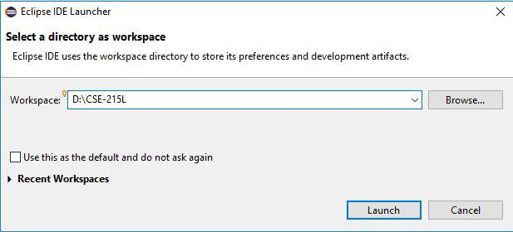

Before you can create Java programs, you need to first create a project. A project is like a folder to hold Java programs and all supporting files. You need to create a project only once. Before creating Java programs in Eclipse, you need to first create a project to hold all files. Here are the steps to create a Java project in Eclipse:

- Choose ​File​, ​New​, ​Java Project ​to display the New Java Project wizard, as shown in Figure 1.
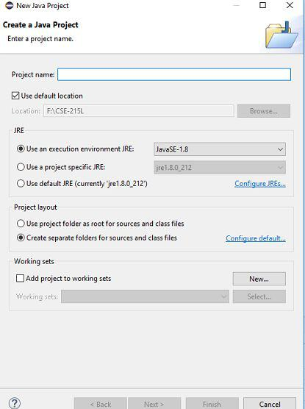

Figure 1: The New Java Project dialog is for specifying a project name and properties
- Type ​Demo ​in the Project name field. As you type, the Location field is automatically set by default. You may customize the location for your project.

- Make sure that you selected the options ​Use the project folder as root for sources and class files ​so that the .java and .class files are in the same folder for easy access.

- Click ​Finish ​to create the project, as shown in Figure 2.
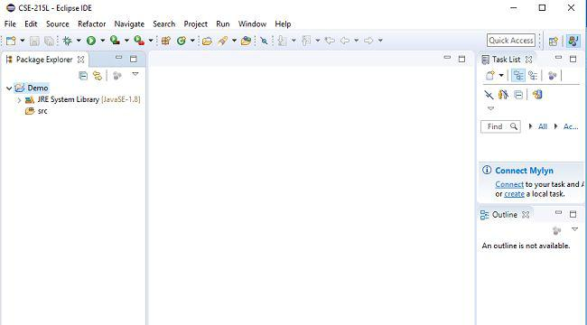

Figure 2. A New Java project named Demo is created.

Step- 2: Creating a Java Class

After a project is created, you can create Java programs in the project using the following steps:
- Choose File, New, Class to display the New Java Class wizard.

- Type Welcome in the Name field.

- Check the option ​public static void main(String[] args)​.

- Click ​Finish ​to generate the template for the source code Welcome.java, as shown in Figure 3.
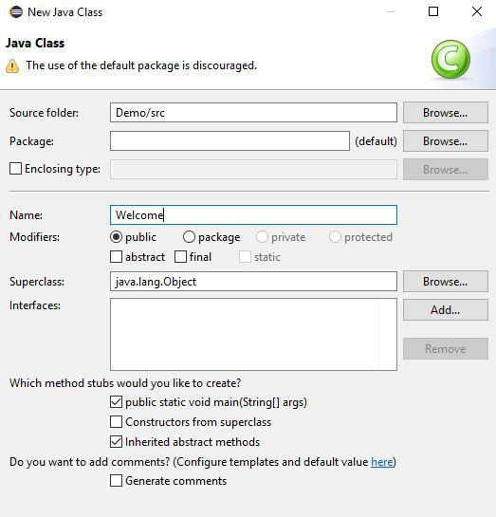

Figure 3: The New Java Class dialog box is used to create a new Java class

Step- 3: Compiling and Running a Class

To run the program, right-click the class in the project to display a context menu.
Choose Run​,​ Java​ Application in​ the context menu to run the class. The output is

displayed in the Console

pane, as shown in Figure 4.
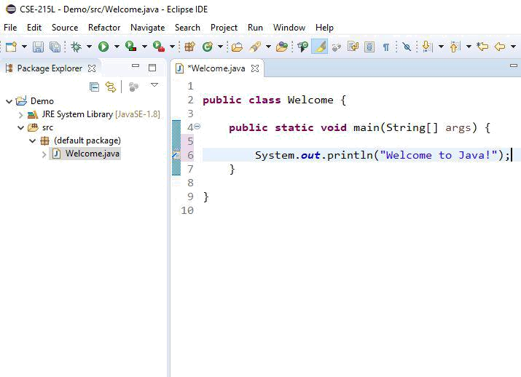

Figure 4: You can edit a program and run it in Eclipse.

Tasks:

- Write a program that prints your name, age, and department in the console.

- Write a program that prints from 1 to 10.

- Write a program that determines if an integer is odd or even.

